Chaupimonte Coffee Mill: Supporting Education Through Coffee Development in Oxapampa
Perú
Colorado College
Lucy Marshall and Eva McKinsey, USA, Colorado College
Project Summary:
The purpose of our project was to create a sustainable link between the economic activity of coffee production and education in the rural mountain town of Ancahuachanan, Peru. Our investment in and development of a local coffee farm called Chaupimonte has enabled the production and export of specialty coffee, resulting in higher revenue, which will in turn, sustain yearly financial contributions to two schools in the community.
Section I: Project Details and Future Plans
Our summer entailed a whirlwind of activities ranging from building coffee solar dryers to teaching children how to operate laptops. Full of surprises that we happily welcomed and others that were not quite as celebrated, this project encouraged patience and adventure, it taught us how to adapt in the face of challenges, it introduced us to harsh yet resilient realities, and it created forever lasting memories with a community we now consider a second home. Tessa Allen de Oliveira, a 2016 graduate of Colorado College, was an integral member of the project since its inception and travelled to Peru with us this summer. Here is a brief summary of our Davis Project for Peace:
After a couple weeks of planning with in-country project partners and advisors in Lima, we headed to the Chaupimonte farm located in a satellite town of Oxapampa called Ancahuachanan. Eager to begin developing the coffee mill, we invited one of our specialty coffee advisors, Paul Cebul, to the farm. By the end of his visit, he had convinced us that it made sense to attempt to produce specialty coffee this year as opposed to simply providing the structures to begin next year. Therefore, within days of arriving at the farm, we kicked into high gear working with a member of the local community to construct a 5x10 meter coffee solar dryer. Directly following the construction of the dryer, we orchestrated a specialized harvest for high quality coffee on the farm and began an extensive experiment of two types of coffee production, natural and honey processing.
After the beans were on the beds and drying, we were able to dedicate more of our time to education. Our first goal was to install Internet in the school of Ancahuachanan, the nearest elementary school to Chaupimonte. We learned that in order to install Internet at the school, the technician had to first install an antenna on a nearby hill, which happened to belong to the town’s mayor. An agreement was therefore reached that the technician could install the antenna on the mayor's hill in exchange for free Internet services at the school. This exciting development freed up some of our funds so that we were able to augment our budget for educational support in the area. This also coincided with a chance meeting of the teacher of the school in the next town over, Pampa Chica. These circumstances along with lower than anticipated costs of mill construction allowed us to extend our education support to include both schools, Ancahuachanan and Pampa Chica. Our contributions included technology to the schools (5 laptops and a projector), installation of Internet at one school, assembly of a swing set, construction of a school grounds fence, funding of a computation course for the teachers, and purchase of educational computer programs, didactic games, sports equipment, school supplies and health and safety resources. These contributions directly impacted about 75 students and teachers.
Alongside our involvement at the schools, we continued our coffee experiments and the construction of the mill. After the coffee dried, we brought it to several labs for cuppings (receiving as high as an 88/100 score!), and to recieve professional advice on how to improve the quality of the coffee in the future. On the farm, we cleared an area that had been used as a coffee plant more than 25 years ago, built a roof over it, cleaned and repaired old washing wells, and installed a new depulper.
Our project concluded with finalizing plans for the future of the project. With Susana Rubio, owner of the farm, we created a bank account solely for her future contributions to the two schools and she has agreed to donate 100% of the profits earned on the coffee we processed this year to the schools. We have already arranged for the coffee to be bought by Paul Cebul through the channels of a Peruvian cooperative called NARSA, and sold in his New York coffee shops (Uptown Roasters) this year. As for the future, due to Chaupimonte's new capability in producing specialty coffee and being able to export, Susana has promised to contribute 20% of the profits earned from her production of specialty coffee to the schools. She hopes to use the savings from this year’s earnings and coming years' harvests to build a school library.
Section II: Project Impact
Throughout this project we found ourselves highly involved in two things that the local community cares deeply about: coffee and their children's education. It was common to have visitors stop by the farm to see what we were constructing or to see how our project was coming along. This introduction of innovative and profitable methods of producing specialty coffee in an area that has previously been rooted in a conventional coffee trade system, a structure that fortifies patterns of inequality and stagnation, is an important first step in ensuring safe and valuable progress in the future. Additionally, encouraging growth and opportunity within the coffee industry was recognized again and again by community members as a way to detract involvement in other more dangerous and informal activities, such as growing and selling coca. Furthermore, our work with Paul, and thus our connection with NARSA, a coffee focused organization committed to upholding the principles of integrity, sustainability, transparency, and empowerment of farm working families, holds promising possibilities for future collaboration between this cooperative and small producers in the Ancahuachanan area.
Our experience in Ancahuachanan also revealed a strong commitment to education. We were constantly amazed by how dedicated the parents were to their children's schooling. When we accidentally planned a meeting with the parents of the school of Ancahuachanan on the same evening as a cockfight (the primary social activity of the community), we were worried about attendance. These concerns were put to rest that night as every student’s parents showed up, excited to contribute their ideas about how we could best support the school. One afternoon, when we arrived to the school of Pampa Chica to drop off materials that we had purchased for the school garden, we found 8 of the students' fathers working hard to install a fence around the school grounds that we funded to improve security. Our contributions to the schools were met with great appreciation from all members of the community, exhibited by multiple invitations to community meals, including our first Pachamanca experience, a traditional Peruvian dish prepared in an "earth oven." One challenge we faced was the realization that the establishment of a community center at the mill was not realistic due to its decentralized location. However, we believe that although we were not able to carry through with this part of the proposal, our support to the schools built on existing structures and systems that already served as local centers of activity and involvement.
Decisions to make project adjustments were fueled and encouraged by one of the greatest lessons we learned this summer: the importance of valuing the existing structures that a community has worked hard to establish as well as recognizing the resilient efforts and abilities a community has to provide for and support themselves. While hearing many stories about the area’s sad history of terrorism both in the 80’s and the recent past, we also had the opportunity to witness how the community consistently comes together to provide structures of support that the state should, but does not always, provide, such as education support. For that reason, we wanted to ensure that our presence this summer was not focused on creating new structures and systems, but rather fortifying those that already existed. Our contributions to the coffee business brought fresh ideas and valuable capabilities to an already established economic activity. Our work at the schools allowed for the efficient implementation of multiple projects that teachers, parents, and students had conceived of themselves. Throughout our time, we learned how the residents of Ancahuachanan not only have been able to eliminate violence from their community, but how they have also learned to construct a society where everyone can, and does, contribute to the community’s well-being; where members have valuable roles and responsibilities; where opportunities can be pursued without fear; where there is a sense of freedom and security; and where challenges, successes, and goals are experienced together. We think that that is what peace looks like. We hope that by strengthening the systems surrounding coffee production and education, we also encouraged and intensified that sense of peace already experienced in the quiet, mountain town of Ancahuachanan.

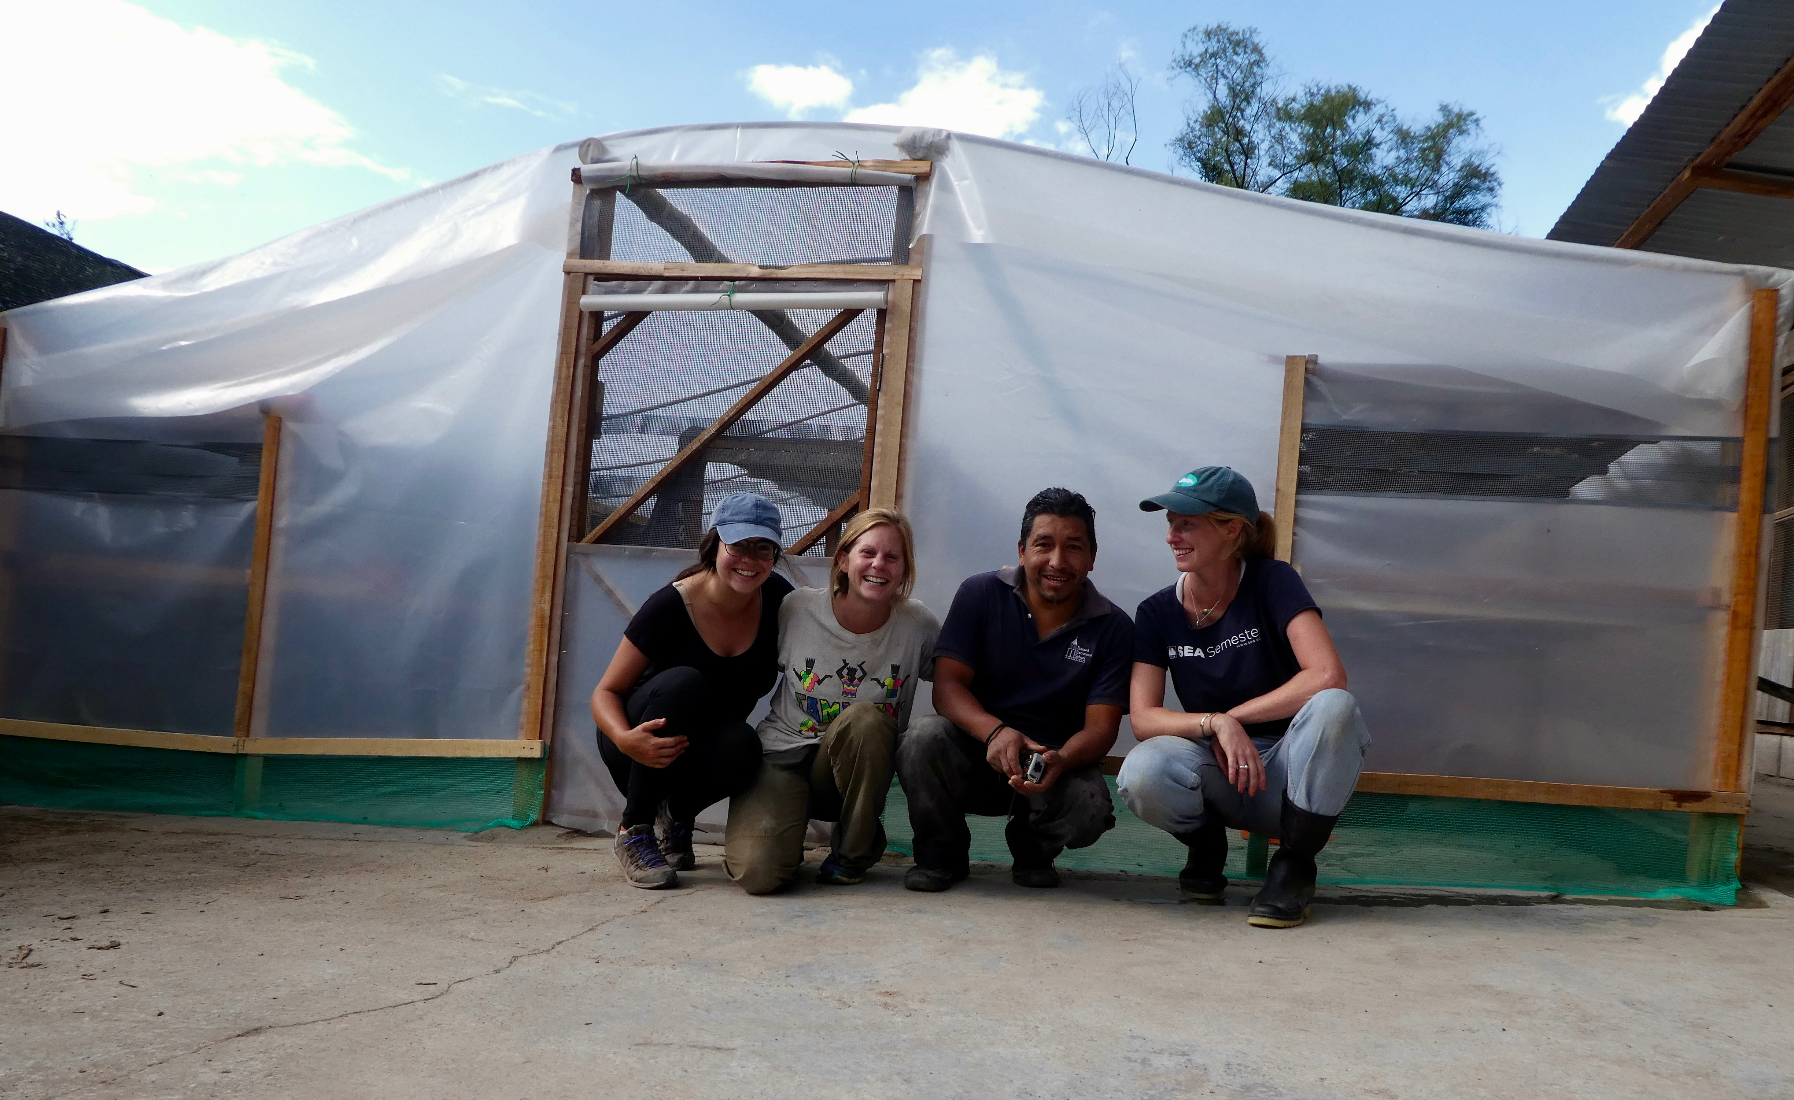
“The opportunity to work with coffee processing and education in the Ancahuachanan region has instilled in each of us a true appreciation for community values, respect for grassroots education efforts, and understanding of entrepreneurial initiative. And beyond that, it has shown us the collective capacity of these 3 forces to bring about and strengthen a sense of peace in a previously unstable area. Through this project, the Davis Foundation has seeded a boundless amount of progress and hope in Ancahuachanan, and we are grateful and honored to be part of the story.”–Lucy Marshall

